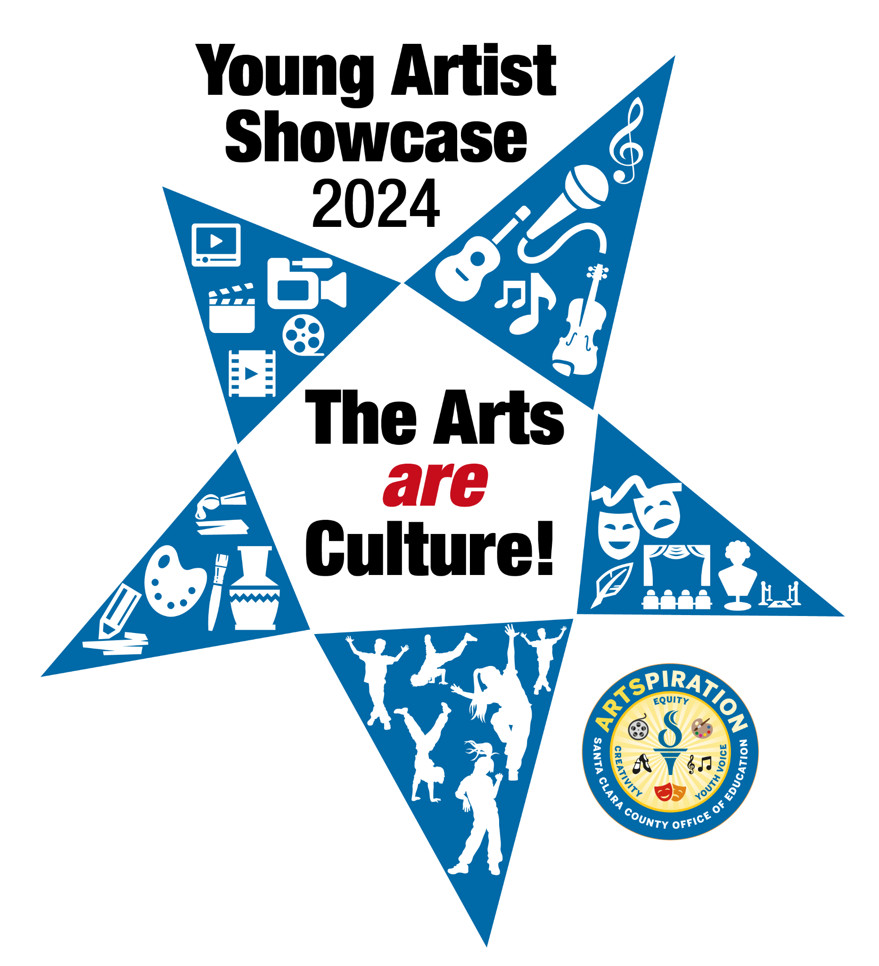Young Artists Showcase 2024:
The Arts are culture!
The Santa Clara County Office of Education announces the 2024 Young Artist Showcase. This showcase is open to public school students, grades Pre-kindergarten through 12th grade, in Santa Clara County. Adjudicators will determine the student artwork to be accepted into the permanent exhibit of student artwork located within the SCCOE campuses as well as showcased at the virtual Young Artist Showcase Celebration on May 16, 2024 at 4:00 p.m. All artwork will be submitted digitally.
Theme - The Arts are culture!
This year’s artwork theme, ‘The Arts are culture!’, encourages youth to imagine, through the arts and creativity, a place of belonging and a valuing of diversity through cultural celebration and creative expression. Understanding, belonging, and empathy are important to thriving in a diverse, contemporary world. Artistic expression is a means for expressing ourselves, our values, and that expression contributes to the mosaic that is the rich ecosystem of Santa Clara County schools.

Eligibility
Digital files of the artwork will be accepted in four (4) categories:
● Visual Arts 2D: Present paintings, drawings, prints, works on paper, canvas, wood, cardboard, mixed media, film/analogue photography. Anything on a flat surface.
● Visual Arts 3D: Present sculpture, installation, glass, metal, ceramics, mixed media with materials coming off the paper, etc. Anything three dimensional.
● Media Arts 4D: Produce new media (podcasts, video, cartoons, infographics) digital photography, illustration, graphic design, photo-shopped images. Anything created on a computer, digital camera, or screen.
● Music, Dance, Theatre Arts: Perform, capture, and submit via YouTube or Vimeo. A submission may be no more than two minutes.
*Note: Artwork and performances can be done alone, with a partner, or with a group of classmates- please include all artists’ names.

Students
● Pre-Kindergarten through 12th grade teachers are encouraged to submit student artwork for selection into SCCOE’s permanent collection.
● All Santa Clara County public/charter schools, public preschool programs, and after-school public programs are eligible to participate.

Submission Requirements
● Preschool to 12th grade artwork will be submitted to SCCOE via an online submission form. Submissions are limited to one artwork per student or group of students if it is a shared project.
● Submissions will be done through the Young Artist Showcase Submission Form found on www.sccoe.org/arts/yas.
● We will accept electronic submissions beginning November 1, 2023 on a rolling basis until April 1, 2024.
● Artwork will be exhibited online on the Young Artist Showcase page of the Artspiration SCCOE website beginning in May and on site at SCCOE’s Ridder Park campus beginning in July 2024.
● An artist’s statement shall be included with each submission. Students are urged to complete the “YAS Student Worksheet” to prepare for the artist statement questions in the submission form. Entries will be disqualified unless the artist statement is included with the artwork submission.
Suggestions on how to photograph and format your artwork to meet submission requirements:
How to Photograph Your Artwork forOnline Submission: ​​How to Photograph your Artwork for Online Submissions
Requirements:
All images should:
- Be in jpeg, or tiff format, sized between 1000 and 2000 pixels
- Have a resolution of 300 dpi. Files should not exceed 3 MB in size.
- Use this naming convention: FirstName.LastName.GrX_YAS2024
Guidelines for photographing and resizing your artwork
○ Free software like www.resize-photos.com or
○ iPhoto instructions https://www.wikihow.com/Shrink-a-Picture
● Create a neutral background for your artwork with a sheet or blank surface. Do not have other objects in the frame with your work.
● For 3D work, think about what direction you want your sculpture to face. You can have 2 photographs on the same file to showcase another view of your work. Please combine the images into one file using a photo editing program. You may email additional photos, if needed.
● Proper lighting will help to project the beauty of your piece – use caution with flash or bright sunlight streaming on to the work.
● Focus carefully on your piece to send the best representation of the work.
● Please do not use Instagram or other filters to edit your work – the resulting color image may not be representative of the actual piece.
● For 4D work, if your file is too large, you may share a link to a Google File or YouTube. Insert this information in the “comments” of the submission form.
Suggestions on how to record your performance to meet submission requirements:
Recording Your Performance: A How-To Guide: Recording For Performance | How-To Guide

Artwork Selection
Judging Criteria for Selection into the Permanent Collection. Pieces will be judged on the following (not in order of priority):
- Interpretation - communicating the theme, an idea, or an emotion
- Imagination and creativity
- Effective use of media as related to content
- Visual (Aural) impact (i.e., bold, strong)
- Originality
- Skill in use of media and technique (visual and media art: use of watercolor, crayons, pencil, ink, video, digital technologies)
- Composition:
  - Effective use of elements of art/theatre/music/dance
  - Effective use of principles of design/musical elements/key theatrical concepts/elements of dance
  - Effective use of compositional/performance technique

People’s Choice Awards will be announced prior to the release of the Online Student Art Gallery on May 1, 2024. Awardees will have a digital file of their artwork added to the permanent collection.
Submit artwork to the 2024 Young Artist Showcase at:
https://sccoe.to/YAS2024​​​​
The deadline to submit artwork is Monday, April 1, 2024​.
Key Dates
2023-24 YOUNG ARTISTS SHOWCASE SELECTION PROCESS:
● November 1, 2023 – April 1, 2024 | Electronic submissions of PK-12th grade student artwork and media
- Week of April 8, 2024 | People’s Choice Awards Adjudication
- May 13, 2024 | Online Student Art Gallery at www.sccoe.org/arts/yas
- May 16, 2024 | Young Artists Virtual Showcase Celebration for all grades: 4:00 p.m.
Young Artist Showcase 2024 guidelines, worksheets, and submissions forms can be found here: www.sccoe.org/arts/yas
Please share this information with teachers, school site administrators, and other interested colleagues. For further details, please contact Sofia Fojas at artspirationsocialmedia@sccoe.org or visit artspiration.sccoe.org.

